Moggill Creek Catchment Group

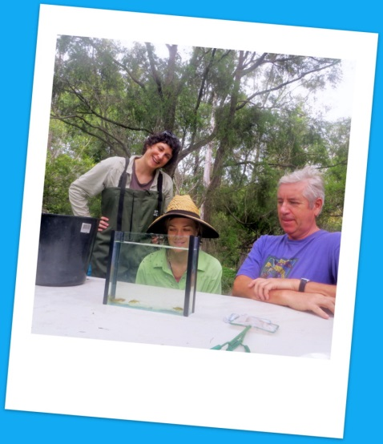
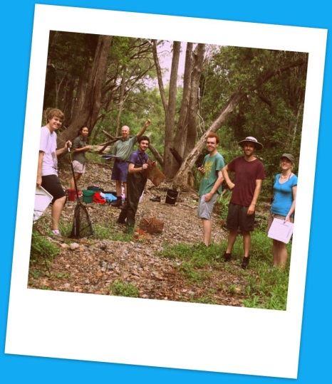
Creek Health Monitoring Project

Next survey – Sunday 27thNovember

Come get involved!

- Help with our long term biannual creek health study
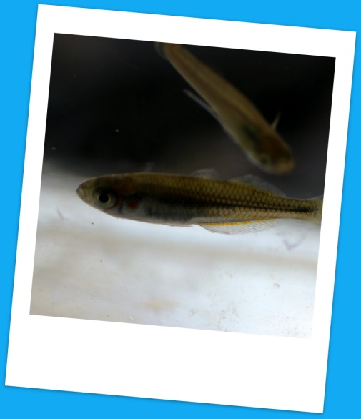
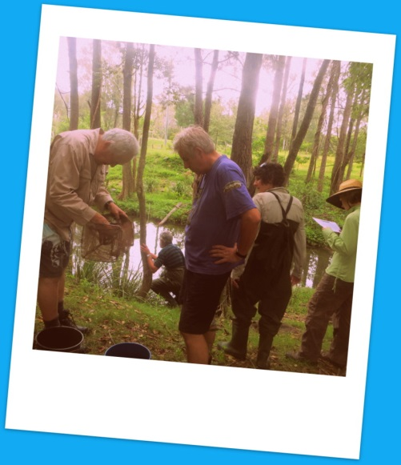
- Learn new skills, gain practical experience in macro-invertebrate and fish identification and meet new friends
- Suitable for all! Perfect for undergraduates or
graduates
- Six teams meet at sites around Brookfield
- Sampling starts around 8am and finishes up
soon after lunch
- Light lunch provided
- Just bring suitable outdoor clothing, water and positive energy!
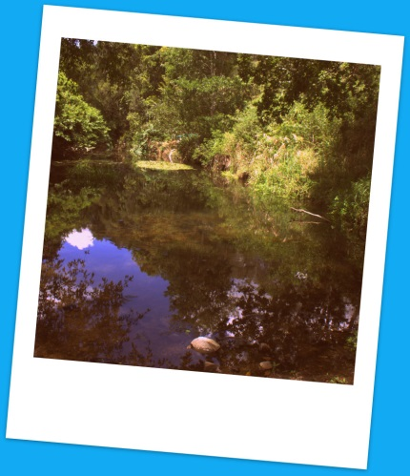
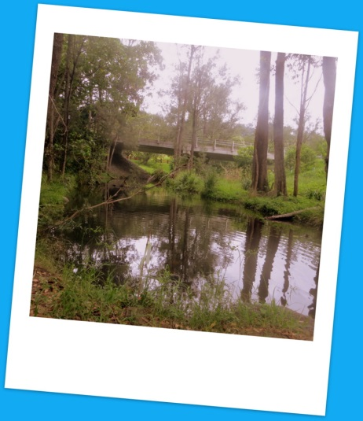
To get involved or find out more join the event page on Facebook which can be found by searching and liking Moggill Creek Catchments
or contact Adrian Webb (Program Leader).
Ph: 0412 672 283Email: adrian@webbnet.com.au

